Let the Confidence Lady entertain and inform your audiences.

Let the Confidence Lady show you how to succeed in business and life

In addition, the Confidence Lady will bring over 26 years of insight in the following topics to your show:

Dating

Always dating the wrong guy…again, and again? Here is why.

Are you settling for less than you deserve?

Next, Next, Next - Move on…quick...hurry…NOW!!!

I hope he/she likes me!

Want your date to fall in love with you?

Make him sacrifice for you/Make her feel safe and loved.

Weight

“Confidence”- one size fits all

Swimsuits and self-esteem

Do only beautiful people have high self-esteem?

Celebrities
What do David Letterman and Kathie Lee Gifford have in common?
Britney Spears, Lindsay Lohan, Paris Hilton… What traits are high and which are low? You might be surprised!

Why do some celebrities die young?

Keys to Instant Self-Esteem

What you should never say to yourself

What are you pretending not to know?

Apples to Oranges - Be Yourself
How managing your time affects your self esteem

Additional Radio/TV Topics
· Key ways to let go of the past
· How to find your Life Purpose
· Life Balance—Plate-Spinners Unite
· Self-Empowering techniques to take your life to a new level
· How to practice Instant Forgiveness
· How to juggle a little Mom time
· How to find your “Momfidence” and raise Confident Kids
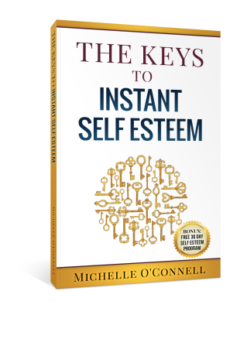
· How to get off the “Ferris Wheel” of Perfectionism

Available at amazon.com

