**Confidence lady** says:

**Michelle O’Connell**

**Is**

**The Confidence Lady**

For greater self-esteem and confidence, you have to … **STOP** the past, **SNAP** the present, and **ANCHOR** the future.

**Confidence lady** says:

Self-Esteem means **I am**

Self-Confidence means **I can**

Self-Worth means **I deserve**

**Confidence lady** says:

The **prince** is not going to show up at your door – you have to go **to the ball**, and you have to **lose the shoe**. Take action now!

**Confidence lady** says:

Stand up and be proud of your **uniqueness**! Live a life of outrageous **excellence**!

I have spent over 25 years in the self-development field. I have coached, entertained and empowered clients all over the world.  This includes well-known clients from the entertainment industry, international business executives and everyday soccer moms. I strive to help each client find the “best within themselves”.

Are you a perfect “10”? Click here - <http://www.youtube.com/confidencelady>

**Available at amazon.com**

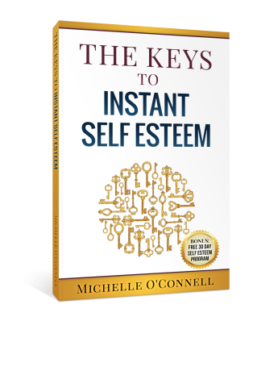

**Confidence Lady**

clients say:

"Michelle was **encouraging and supportive in coaching me** as I struggled with the truths about myself and **helped me refocus on the positive steps I needed to take**”

“**She wowed our audience**…..she is smart, funny and quick on her feet”

"I am grateful for Michelle’s ability to hold my hand. **I am honored by her wise ability to let me have a very unique experience with her techniques."**

"Michelle assisted me in uncovering the blocks to my greater success. **Since I have worked with Michelle I have greater confidence and a clearer picture of my goals**."

“Michelle is a dynamic, intuitive life/success coach. She changed my perspective and **it changed my life. I am forever grateful.”**  
    
“I have **made huge strides** toward the **huge goals** I want to achieve under Michelle's guidance. Michelle helps keep me on track by reinforcing within me the idea that **anything is possible in life**. She offers supportive, insightful guidance with a positive motivational style**. She is also very entertaining”**